2021 Kings and Queens of the Ramp
Hosted by Manukau Outrigger Canoe Club
Saturday 10th July 2021
The Ramp, Ian Shaw Park, Mt Wellington

High tide 07.33am 2.9m

8km W6 Junior and Novice only
14km W6 Open, Master, SM, GM, M70
(Mens, Womens, Mixed)

Race Programme;

7.00 am : Arrive, Rigging, Registration
Nga Hau Maiangi Building, The Ramp, Ian Shaw Park

7.45 am : Safety checks commence

8.15 am: Race Briefing - 8km W6
9.00 am: Race Start - 8km W6

9.45 am: Race Briefing - 14km W6
10.30 am: RACE START - 14km W6

12.00 pm: End of day and hot soup

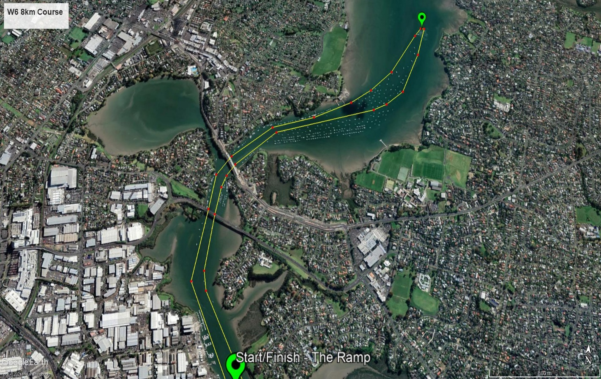

8km race course:
- Start in front of the pontoons at the Ramp.
- Head north following the channel past the two bridges
- Ama turn at the last green pole channel marker
- Head back N/E towards Tamaki wharf staying to the RIGHT- hand side of the channel
- Past the two bridges keeping to the RIGHT – hand side of the channel
- Finish back at the Pontoons keeping to the RIGHT – hand side of the channel

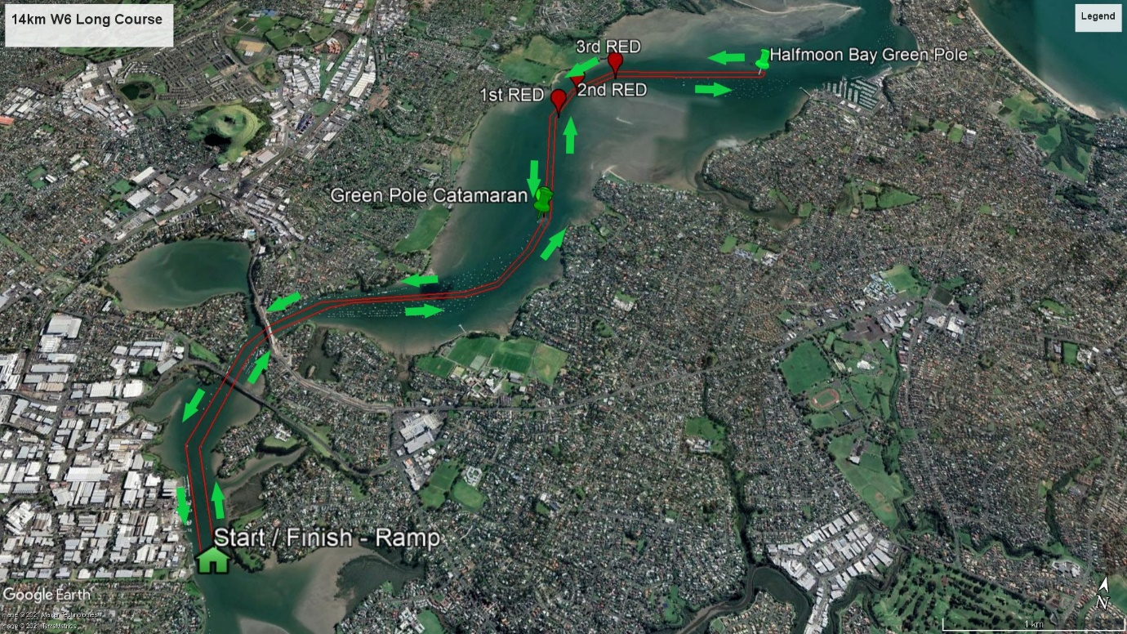
14km race course:
- Start in front of the pontoons at The Ramp
- Head north past the two bridges
- Follow the channel markers then ama turn at the Half Moon Bay channel marker

- Head back N/E towards Tamaki wharf staying to the RIGHT- hand side of the channel
- Past the two bridges, keeping to the RIGHT – hand side of the channel
- Keeping to the RIGHT – hand side of the channel, finishing back at the The Ramp pontoons.

